# Tell me about your self

* My self-Sujeet kumar.
* By academic – I have done Master in computer application
* I have working on .NET technology for long time along with AWS cloud
* I am very curious kinds of person and very quick in learning and implementing efficiently

# Rule

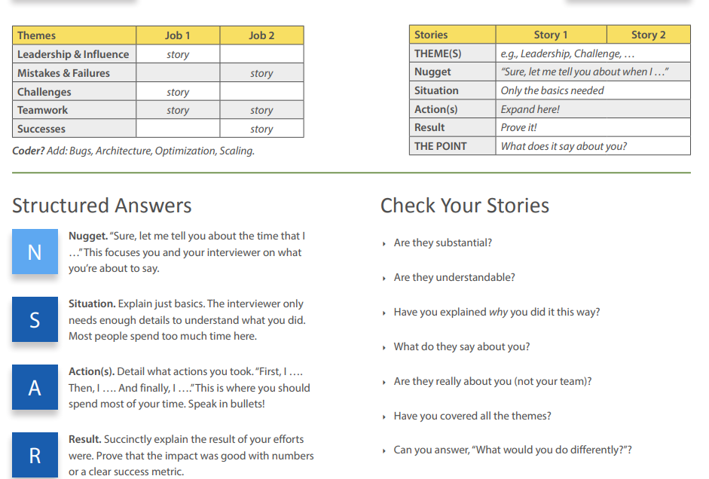

# STAR (Situation/Task, Action, and Result) Method

* **Situation**: An event, project, or challenge faced.
* **Task**: Your responsibilities and assignments for the situation.
* **Action**: Steps or procedure taken to relieve or rectify situation.
* **Result**: Results of actions taken.

# STAR 1

**Situation:**

In one of my projects, we are developing multiple microservice and **challenged** was to have a communication between microservice to send event from one microservice to another microservice

**Task:**

1. Enable microservice communication

**Action:**

1. We used AWS SNS to send event from microservice to AWS SNS Topic and there was a AWS Lambda function subscribed to that AWS SNS.

**Result:**

1. We established successful microservice communication

# STAR 2

**Situation:** **Based on Start 2**

As I mentioned before that we needed to establish microservice communication but there was a challenge so allow me to elaborate so that it helps all to understand.

So, there was two microservice Merchant Module microservice and Transaction processing microservice where only Active Merchant can make payment using transaction processing microservice.

So whenever Merchant daily transaction limit increases greater than 70 % then Transaction Processing microservice must send an event to merchant module microservice to update merchant status to HOLD so that merchant no longer can make transaction and all this microservice communication was happening through AWS SNS **but problem was that sometime AWS is down or company firewall change transaction processing could not send event to merchant module then how make sure that failed event is always re-send later**

Task:

1. The task and plan were to find a way to have retry mechanism of failed event between microservice

Action:

1. So there was twostep process int his.
   1. One Transaction processing microservice must write event to Transaction processing Database before publishing event to AWS SNS topic for merchant management microservice
      1. If event is successfully published then delete the event from DB
      2. Otherwise, we developed a lambda function which was scheduled to run every hour by chron job to fetch all failed event and publish the event again once event is published successfully then delete the event from DB

Result:

# STAR 3

**Situation**:

I was working in one of the projects where Toyota dealers use to access website and website response time was very slow so I was assigned this task by my manager to analyse and optimize it

**Task:**

1. Analise and find why it is happening
2. Optimise it

**Action**:

1. First, I went through project as whole and tried to see what others external components / web service was called
2. I found that Project is using a Legacy dll coded in visual basic programming
3. So, I shared this to my manager and next action plan was to replace this legacy dll
4. But the main challenge was that there was no documentation around legacy dll to understand the code and logic so we tried to decompile it and tried to understand code and logic and based on that we re-developed in latest code framework -4.6
5. Next challenge we faced while re-developing that legacy code was calling Oracle Database procedure. As we were fully working on SQL Server having no knowledge of Oracle was challenge and also the way it was called from legacy dll and the way .NET code support to call was bit different so we explored and researched little bit and make it happen

**Result**:

1. The performance of site was fast and customer was really happy and for same I was awarded UNIT level for best performance optimization

# STAR 4

Situation:

Task:

Action:

Result:

# STAR 5

Situation:

Task:

Action:

Result:

# The most common questions are:

1. **Tell me about a time when you were faced with a challenging situation. How did you solve it?**
   1. Manage to lead and meet the timeline
   2. Handling one module + Manager aksed to handle another module
2. **Do you usually set goals at work? If yes, could you give me an example of a goal you had and how you achieved it?**

* Break down big chunk into smaller chunk – that help to estimate cost wise and effort wise, different person can work on many tasks at same time. Track

1. **Give me an example of a time you made a mistake at work.**
2. **Have you ever faced conflict with a coworker? How did you resolve the situation?**
   1. Mostly I am very cooperative and friendly with my co-worker.
   2. Whenever Some has conflict that most of the time, Then need to understand the cause of conflict
   3. they have very tight timeline or
   4. some personal problem in that case I try to be helpful as much as possible or if I can contribute in their work
   5. Not able to understand my point of understanding and idea to resolve the issue
3. **Tell me about a time when you handled the pressure well.**
   1. Developer to TEAM lead
   2. Manage stackholder
4. **Was there a time when you had to be very strategic in order to meet a goal?**
   1. Developer to TEAM lead
   2. Manage stackholder
   3. Break down task
5. **Give me an example of a situation when you showed initiative and took charge of a situation.**
   1. Developer to TEAM lead
   2. Manage stackholder
6. **Tell me about a time when you went above and beyond your duties for a job or task.**
7. **Did you ever have to correct one of your superiors when they were wrong? How did you approach that situation?**
   1. I take that offline and talk one to one with pros and cons of solution suggested by supervisor and any better idea I have
8. **Have you ever had to work under a tight deadline?**
   1. Always
9. **How do you deal with coworkers that don’t cooperate or can’t contribute enough?**
   1. Two things here – capable of contributing but not contributing other seems not capable of contributing
   2. Second who is not able to contribute I coach, train and support in all aspect of learning and implementing
   3. First who is capable of contributing –
      1. I made the owner of that feature/PBI and task.
      2. I request and approach as leaner to know something so that same I can understand and same impart in team so that work is not hampered
10. **Tell me about a time when a client was asking for the impossible. How did you explain and communicate this to them?**
    1. Break down the task that is easy to understand and cane estimated in time and can be visualize
    2. Show the resource bandwidth and task complexity
    3. Help to make understand that quality will be compromised
    4. Try to come with MVP minimum viable product
    5. A trust Relationship is very important here that help to win client confidence
11. **Give me an example of a time when you didn’t meet a client’s expectations. How did you deal with the situation?**
    1. Inform well in advance and communicate if any uncertainty
    2. Show what caused to delay, was this communicated effectively on time
    3. Put genuine effort to come with alternative plan in minim time
12. **Is there a situation you think you could’ve handled better or differently?**
13. **How do you adapt to sudden changes in the workplace? Could you give me an example?**
    1. I am very much adaptable in term of people, in term of technology, in term process because I believe that flexibility is the only way to grow
    2. First try to understand and learn new process and adapt slowly to it
14. **What was the first job you ever had? Do you remember how you adapted and learned the ropes?**
    1. I joined and just my senior left in few days
15. **Tell me about a time when you had to think on your feet in order to deal with a situation.**
    1. I joined and just my senior left in few days
16. **Sometimes employers put too much on their employees’ plates. Was there a time when you were overwhelmed with work? How did you handle the situation?**
    1. Prioritize, Breaking down big chunk into smaller chunk, MVP
17. **Tell me about a time when you had the liberty to be creative with your work. Was it exciting or difficult for you?**
    1. This is where I come excellent and put something new on table. This is what excite me more and make me go getter.
18. **Give me an example of a time when you and your team had opposing views on an issue. How did you persuade them to go with your decision?**

* I believe in open discussion and very much to accept better and effective idea. If there is opposing view then I can show this to someone who he trust and believe and put the presentation on table

# Behavioural

## **Have you ever faced conflict with a coworker? How did you resolve the situation? Or** tell me about a time when you overcame a difficulty

### **Situation**

1. Normally I am very friendly kinds of person and mingle well with all sort of employee
2. But there was time, A Business Analyst was introduced in team

### Task

1. My manager told to work with Business Analyst to refine and understand requirement and bring it to workable state for team and map it technically.

He normally did not share all the details and fact and later tell that it was also part of requirement and application not working as per expectation

He also did not involve me in any requirement discussion. He also did not reply in meeting whenever I ask the question that led to gap in requirement and delay development

### Action:

1. I requested to have one to one talk privately and explained the scenario that due to requirement gap I and our team is getting delayed and it hampering project deadline and work.
   1. we together established thumb rule that requirement document will be shared in advance to development team
   2. Set up a meeting and talk openly of any question
   3. Sign off of requirement document from business analyst
   4. He agreed and we become fine in all aspect.

### Result:

1. We started to develop as per expectation and requirement and project delivered on time.

# What is your opinion on failure?

* Failure Is Success in Progress by albert Einstein.
* Everything that is successful today was failure in the beginning
* So, Failure is just one step learned lession toward success

# If you had to build a team from the ground up, what qualities would you look for?

--Bounce back quality

--Failure do not break but motivate to do differently

--Quick leaner and implementer

-- Attitude to go beyond duties

-- Hands On and Can-do attitude

-- Work without supervision

John Deere is a brand name of Deere & Company, a renowned American company that is into the **manufacturing of agricultural, construction, diesel engines, drive trains, and forestry machinery** which are used in heavy equipment and lawn care equipment.

1. Recount a time you had to be creative to solve a problem.
2. Can you relocate if you are asked to?
3. How do you overcome the challenges that surface during projects?
4. Tell us a bit of your past projects.
5. Tell us about a time you had to make the right decision over a popular one.
6. What can you say is the basic difference between interface and abstract class?
7. Tell us about a time you had to show courage in order to overcome a particular challenge.
8. Which of the departments are you interested in working in?
9. How do you cope with working alongside someone you don’t like?
10. Tell us about a time you failed by your standards

# MISTAKE and Failure theme

## Option 1 - Team lead

1. **Give me an example of a time you made a mistake at work.**
2. **S-** In one of my projects, I was leading Team for very first and my team wasn’t reaching its project deadline.

The problem was that I use to **take more work myself** to make sure everything is correct and quickly became overloaded and **could not help Team in other aspect** –

1. **A –** Later, I realized it that there are lots of things that is not happening and I needed to correct it. I called a meeting and asked each of the member to be open and tell me what is the issue that they are facing to complete on time.
   * 1. **I made a checklist** of it and found many things like
        + Requirement was not well capture
        + Requirement is well not understood
        + Team does not have knowledge of whole application so not able to think impact
     2. Acceptance criteria not well recorded
        + Dependency and blocker on third party and other dev team
        + Not discussing the issue within team
        + No proper peer code review
        + Not putting deadline in mind at daily basis.
        + Not opening up when they need helping hand
     3. First, I started to distribute the work among team as per bandwidth and velocity so that I get more time to discuss with my TEAM and help them to achieve their task.

I also Started to **mentor and coach them** wherever they are lacking in term of domain knowledge and technical knowledge.

I also made sure that there is weekly KT session for whole application so that team has better visualization of application

I started to put weekly meeting with all stack holder to understand expectation

I also worked on blocker and dependency that my team is facing and resolved it ahead of time so that my team is fully focused in task to implement.

I also worked on requirement and PBI and made sure that all requirement is properly capture and accurate and my team understood well what is needed to do.

That experience taught me focus on my role as a leader, delegating and supporting my team, instead of doing everything myself.

**Result** - As result my team started to perform well and started to meet deadline and we continuously did not miss deadline any time in 1 year and we became first team in whole account that has first-hand opportunity in any new initiative. For same reason whole team was awarded with some GEMS

## Option 2 - Meeting setup

* 1. Set a meeting of time difference
  2. Very early of my career – I use to ask for work again and again
  3. Once Task is assigned it always in my mind to complete it so I done all my work and created a PULL request and wanted to deploy same day

# Leadership & Influence theme -

## Option 1

--- used aws sns microservice and influence all to use it . poc – aws sns , rabit MQ,

--- less time , compatible with aws as whole app is on aws

## Option 2

# Teamwork – Repeat – All of the task I took my self

## Option 1

## Option 2

# Challenges – Senior Developer to TEAM LEAD, directly became front to stack holders

## Option 1

**Situation**

1. **In** one of the projects, I joined as senior developer in one of the critical and time crunching timeline project **and** after few weeks, my manager approached to lead whole team to execute a complex project as project was not meeting the deadline so working as individual contributor to lead entire team was a quit challenging task.

**Action**

* I took the challenge and promoted to Team Lead.
* I started to put weekly meeting with all stack holder to understand expectation
* Repeat
  + Called team meeting
  + Understood why team is not able to meet deadline
  + Made a checklist
    - Requirement was not well capture
    - Requirement is well understood
    - Team does not have knowledge of whole application so not able to think impact
    - Acceptance criteria not well recorded
    - Dependency and blocker on third party and other dev team
    - Not discussing the issue within team
    - No proper peer code review
    - Not putting deadline in mind at daily basis.
    - Not opening up when they need helping hand
    1. First, I started to distribute the work among team as per bandwidth and velocity so that I get more time to discuss with my TEAM and help them to achieve their task.

I also Started to **mentor and coach them** wherever they are lacking in term of domain knowledge and technical knowledge.

I also made sure that there is weekly KT session for whole application so that team has better visualization of application

I also worked on blocker and dependency that my team is facing and resolved it ahead of time so that my team is fully focused in task to implement.

I also worked on requirement and PBI and made sure that all requirement is properly capture and accurate and my team understood well what is needed to do.

That experience taught me focus on my role as a leader, delegating and supporting my team, instead of doing everything myself.

**Result** - As result my team started to perform well and started to meet deadline and we continuously did not miss deadline any time in 1 year and we became first team in whole account that has first-hand opportunity in any new initiative. For same reason whole team was awarded with some GEMS

## Option 2

# Successes

## Option 1

## Option 2

# John Deer

# How you find resource that u need to work

**Situation –**

Sure, let me tell you about when I was working in one of the projects and I needed to modify one Rule engine logic but no clue about this rule engine module.

**Action**

**First**, I tried to find related document in **company document repository to find if there is any KT recorded video or any related document have** and found few docs **then** I tried to find who **else has work previously on this module** but found that he is no longer in company so Went through all document that I found in document repository.

I also looked for help from **online official documentation** and **online** **official forum.**

**Result**

Finally, I was able to find all required resources and fact that I need to modify the rule engine and I successfully complete my task and deployed in production.

# Preparation